2019 Enrollment Microsite
McDonald’s Corporation
Draft 1: August 21, 2018

Variable content is marked throughout this manuscript as follows:
<Staff/RM>
<Crew >
<Staff/RM – HI>
<Crew - HI>

Home Page Graphic Layout

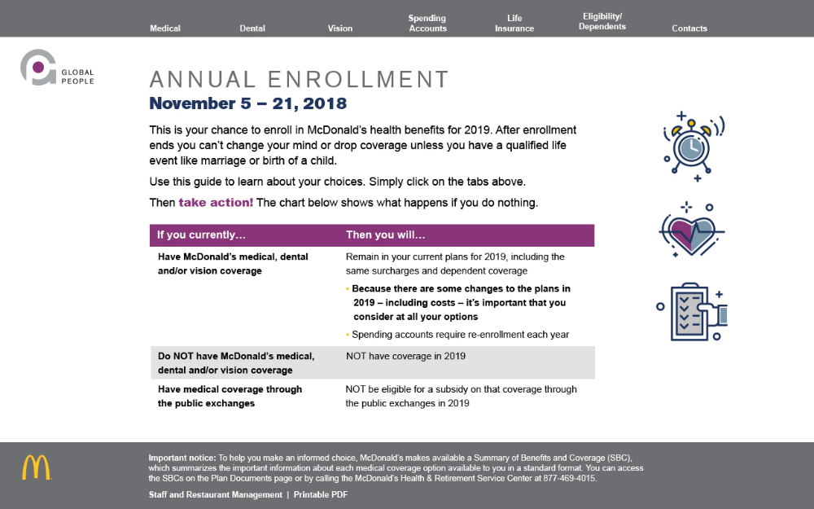
Sub Pages Graphic Layout
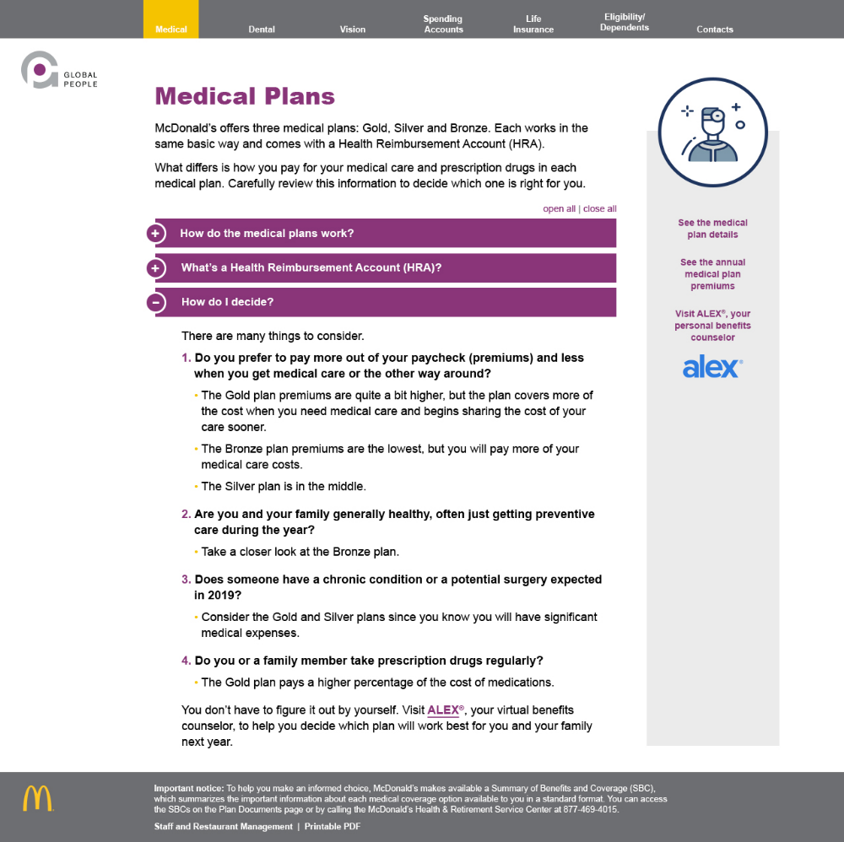

Navigation on every page

Medical Dental Vision Spending Accounts Life Insurance Eligibility/Dependents Contacts

Home page

Annual Enrollment
November 5 – 21, 2018

This is your chance to enroll in McDonald’s health benefits for 2019. After enrollment ends you can’t change your mind or drop coverage unless you have a qualified life event like marriage or birth of a child.
Use this guide to learn about your choices. Simply click on the tabs above. (This direction will need to change if the navigation is elsewhere.)
<Crew >Once you sign up, you are responsible for making premium payments all year. If you do not make your premium payments (for example, if your hours are reduced during the year and your paycheck is not enough to cover your premium), your coverage will be cancelled for the rest of the year.
Then take action! The chart below shows what happens if you do nothing.
If you currently… | Then you will…
Have McDonald’s medical, dental and/or vision coverage | Remain in your current plans for 2019, including the same surcharges and dependent coverage  - Because there are some changes to the plans in 2019 – including costs – it’s important that you consider at all your options  - Spending accounts require re-enrollment each year
Do NOT have McDonald’s medical, dental and/or vision coverage | NOT have coverage in 2019
Have medical coverage through the public exchanges | NOT be eligible for a subsidy on that coverage through the public exchanges in 2019
<Staff/RM - HI><Crew - HI>Hawaii residents: If you choose not to enroll in a McDonald’s medical plan, you must complete the HC-5 form that will be mailed to your home and return it by December XX, 2018.
<Crew> Prominent call-out box or tile
View the content of this website in Spanish. Translated into Spanish
<Links to Printable Content PDF in Spanish>

Footer on every page:
Important notice:
To help you make an informed choice, McDonald’s makes available a Summary of Benefits and Coverage (SBC), which summarizes the important information about each medical coverage option available to you in a standard format. You can access the SBCs on the Plan Documents page or by calling the McDonald’s Health & Retirement Service Center at 877-469-4015.
<Staff/RM> Staff and Restaurant Management I Printable PDF <Links to Printable Content PDF for Staff/RM>
<Crew> Crew I Printable PDF <Links to Printable Content PDF for Crew>
<Staff/RM – HI> Staff and Restaurant Management - Hawaii I Printable PDF <Links to Printable Content PDF for Staff/RM - HI>
<Crew – HI> Crew – Hawaii I Printable PDF <Links to Printable Content PDF for Crew - HI>

Medical Plans
<Staff/RM><Crew>
Medical Plans

McDonald’s offers three medical plans: Gold, Silver and Bronze. Each works in the same basic way and comes with a Health Reimbursement Account (HRA).

What differs is how you pay for your medical care and prescription drugs in each medical plan. Learn more about the plans to decide which one is right for you.

On this and all pages, accordion tabs are closed, but can be opened by visitors who want more information
- How do the medical plans work?
Under all three medical plans:
- You pay a premium to have coverage. This is the amount that comes out of your paycheck.
- You pay nothing for covered in-network preventive care, like your annual physical and related lab work.
- McDonald’s puts money into your Health Reimbursement Account (HRA). Your HRA automatically pays for your eligible non-preventive medical expenses – like doctor’s visits or medical procedures until it runs out. In this way, it helps you pay your annual deductible.
- After you spend your HRA dollars, you pay the full cost of your health care until you reach your annual deductible.
- After reaching the deductible, you and McDonald’s share the cost of your medical expenses through coinsurance.
- If you reach your out-of-pocket maximum, then McDonald’s pays 100% of eligible medical expenses for the rest of the year. In other words, the out-of-pocket maximum is the most you’ll pay in coinsurance and deductibles for medical care, mental health/substance abuse services and prescriptions combined before the plan pays 100%.*
Check out an infographic showing how this works <Links to PDF with infographic from last year’s guide>
*There are some costs that do not count towards your out-of-pocket maximum. These include: Ineligible charges; amounts over reasonable and customary fees; penalties if you don’t pre-certify hospital admission; $5 copays for prescriptions from an out-of-network pharmacy; the $25 penalty for a maintenance prescription at a retail pharmacy after three 30-day fills; and amounts you pay for brand-name drugs when a generic is available.
- What’s a Health Reimbursement Account (HRA)?
It’s free money from McDonald’s to help you pay for your health care. No matter what medical plan you select, McDonald’s puts money in your HRA. How much you get depends on which medical plan you choose.
Your HRA is ONLY used for medical costs. It does not cover preventive, dental or vision expenses. It can also cover Virtual Visits copays – as long as funds are available.
Here are some important things to understand about the money in your HRA:
- If you are in a McDonald’s plan in 2018 and have money left in your HRA at the end of the year, you can keep it in 2019, as long as you participate in a McDonald’s plan again. The most you can rollover into the next year’s HRA is $500 for employee-only coverage and $1,000 for all other coverage levels. You will still receive the 2019 contribution from McDonald’s.
- You only use your HRA dollars while you work at McDonald’s. You can’t take HRA dollars with you if you leave the company.
- How do I decide?
There are many things to consider.
- Do you prefer to pay more out of your paycheck (premiums) and less when you get medical care or the other way around?
  - The Gold plan premiums are quite a bit higher, but the plan covers more of the cost when you need medical care and begins sharing the cost of your care sooner.
  - The Bronze plan premiums are the lowest, but you will pay more of your medical care costs.
  - The Silver plan is in the middle.
- Are you and your family generally healthy, often just getting preventive care during the year?
  - Take a closer look at the Bronze plan.
- Does someone have a chronic condition or a potential surgery expected in 2019?
  - Consider the Gold and Silver plans since you know you will have significant medical expenses.
- Do you or a family member take prescription drugs regularly?
  - The Gold plan pays a higher percentage of the cost of medications.
You don’t have to figure it out by yourself. Visit ALEX®, your virtual benefits counselor, to help you decide which plan will work best for you and your family next year.

Sidebar to the right of the body content
See the medical plan details <Links to PDF - >
See changes to the medical plans. <Links to PDF - >
<Staff/RM>See the annual medical plan premiums and surcharges <Links to PDF – Chart showing annual premiums>
<Crew> See how much comes out of your paycheck to pay for the medical plans <Links to PDF – Chart showing weekly and biweekly premiums>
Visit ALEX®, your personal benefits counselor <Links to ALEX>

<Staff/RM-HI>
Medical Plans

McDonald’s offers three medical plans: HMSA HMO, Kaiser HMO, and XXXXX.

Sarah: Can you provide a high level description regarding why someone would choose one over the other?

- What are the medical plan details?
 | HMSA HMO Plan | Kaiser HMO Plan | HMSA PPO Plan
Annual Deductible | None | None | None
Annual Out-of-Pocket Maximum | Medical:  $2,500 Individual / $7,500 Family; Prescription Drugs (separate from Medical): $3,600 Individual / $4,200 Family | $2,000 Individual;  $6,000 Family | Medical:  $2,500 Individual / $7,500 Family; Prescription Drugs (separate from Medical): $3,600 Individual / $4,200 Family
Basic Medical Care
Primary office visit | $20 copay | $15 copay | $14 copay
Specialist office visit | $20 copay | $15 copay | $14 copay
Maternity, newborn care (including hospitalization) | 90% of eligible charges covered | $15 copay for initial visit to confirm pregnancy; 100% covered thereafter  100% covered Delivery and Inpatient baby care | 80% of eligible charges covered
Hospital (covered hospital services, inpatient and outpatient surgery) | 90% of eligible charges covered | 100% covered | 80% of eligible charges covered
Emergency room treatment | $100 copay | $75 copay | 80% of eligible charges covered
Lab tests, X-rays | Diagnostic testing: 90% of eligible charges covered for Hospital Inpatient (IP); 80% of eligible charges covered for Hospital Outpatient (OP);  Laboratory & Pathology, X-Ray: 90% of eligible charges covered for Hospital IP, $10 copay for Hospital OP;  Imaging (CT / Pet Scans, MRIs): 90% of eligible charges covered for Hospital IP, 80% of eligible charges covered for Hospital OP | 100% covered Inpatient;  90% covered Outpatient | Diagnostic testing: 80% covered; Laboratory, pathology & blood work:  100% covered; Imaging (CT/Pet scans, MRIs):  80% covered
Eye exams | $20 copay, one per calendar year | $15 copay for Optometrist or Ophthalmologist exam | ???
Mental Health and Substance Abuse Services
Inpatient benefits | 90% covered | 100% covered | 80% covered
Outpatient benefits | $20 copay for physician services;  No copay for hospital and facility services | $15 copay Individual / Group Visits | $14 copy for physician services; 80% covered for hospital and facility services
Prescription Drugs
Retail | $7 Tier 1 / $30 Tier 2 / $30 copay & $45 cost share Tier 3;  One retail copay for  1-30 days supply, two retail copays for 31-60 days supply, three retail copays for 61-90 days supply | $3 Generic (maintenance) /  $10 Generic (all other) / $35 Brand (all) | $7 Tier 1 / $30 Tier 2 / $30 copay & $45 cost share Tier 3;  One retail copay for  1-30 days supply, two retail copays for 31-60 days supply, three retail copays for 61-90 days supply  Out-of-network pharmacy:  You pay more for generics. There is no coverage for Tier 2 and Tier 3
Mail Order | $11 Tier 1 / $65 Tier 2 / $65 copay & $135 cost share Tier 3;  One mail order copay for 84-90 days supply at a retail network or contracted mail order provider |  | $11 Tier 1 / $65 Tier 2 / $65 copay & $135 cost share Tier 3;  One mail order copay for 84-90 days supply at a retail network or contracted mail order provider
  $6 Generic (maintenance) /
  $20 Generic
  (all other) /
  $70 Brand (all)
Specialty drugs  (30-day or less supply) | $100 copay on most preferred specialty drugs; $200 copay on most other brand-name specialty drugs  (Specialty not covered at mail order) | $200 copay  for specialty drugs  (Specialty not covered at mail order) | $100 copay on most preferred specialty drugs; $200 copay on most other brand-name specialty drugs  (Specialty not covered at mail order)
Wellness Care | Benefits covered at 100% with no coinsurance
Preventive care (such as annual check-ups and well-baby care) | Covered at 100%
Immunizations and inoculations | Covered at 100%
Annual mammogram or screening colonoscopy (every 5 years) | Covered at 100%

- What are the annual premiums for the medical plans?

 | You Only | You + Spouse/ Domestic Partner | You + Child(ren) | You + Family
HMSA HMO Plan | 1.5% of gross wages | $X,XXX.XX | $X,XXX.XX | $X,XXX.XX
Kaiser HMO Plan | 1.5% of gross wages | $X,XXX.XX | $X,XXX.XX | $X,XXX.XX
HMSA PPO Plan | 1.5% of gross wages | $X,XXX.XX | $X,XXX.XX | $X,XXX.XX

Note: Your premiums for the health plans are normally deducted before federal, and in most states, state income taxes come out of your pay. If you cover a domestic partner, your premiums are before-tax for your partner and any children you certify are your dependents for federal income tax purposes. Otherwise, you will be paying for your covered partner and his or her children after taxes; and you pay taxes on the full premium (your employee cost and the company-paid portion) for their coverage.
<Crew-HI>
Medical Plans

McDonald’s offers the HMSA (Crew) HMO Plan.

Sarah: Can you provide a very high level description of the plan.

- What are the medical plan details? Sarah: No prescription drug coverage in this plan? If so, it wasn’t included in last year’s chart.
Annual Deductible | None
Annual Out-of-Pocket Maximum | Medical: $2,500 Individual / $7,500 Family
Basic Medical Care
Primary office visit | $20 copay
Specialist office visit | $20 copay
Maternity, newborn care (including hospitalization) | 90% of eligible charges covered
Hospital (covered hospital services, inpatient and outpatient surgery) | 90% of eligible charges covered
Emergency room treatment | $100 copay
Lab tests, X-rays | Diagnostic Testing: 90% of eligible charges covered for Hospital Inpatient (IP); 80% of eligible charges covered for Hospital Outpatient (OP);  Laboratory & Pathology, X-Ray: 90% of eligible charges covered for Hospital IP, $10 copay for Hospital OP;  Imaging (CT / Pet Scans, MRIs): 90% of eligible charges covered for Hospital IP, 80% of eligible charges covered for Hospital OP
Eye exams | $20 copy, one per calendar year
Mental Health and Substance Abuse Services
Inpatient benefits | 90% for physician, hospital and facility services
Outpatient benefits | $20 copay for physician services;  No copay for hospital and facility services
Wellness Care | Benefits covered at 100% with no coinsurance
Preventive care (such as annual check-ups and well-baby care) | Covered at 100%
Immunizations and inoculations | Covered at 100%
Annual mammogram or screening colonoscopy (every 5 years) | Covered at 100%

- What are the base annual premiums for the medical plan?

You Only | You + Spouse/ Domestic Partner | You + Child(ren) | You + Family
1.5% of gross wages | $X,XXX.XX + 1.5% of gross wages | $X,XXX.XX + 1.5% of gross wages | $XX,XXX.XX + 1.5% of gross wages

Note: Your premiums for the health plans are normally deducted before federal, and in most states, state income taxes come out of your pay. If you cover a domestic partner, your premiums are before-tax for your partner and any children you certify are your dependents for federal income tax purposes. Otherwise, you will be paying for your covered partner and his or her children after taxes; and you pay taxes on the full premium (your employee cost and the company-paid portion) for their coverage.
Dental Plans
<Staff/RM><Crew><Staff/RM-HI>
Dental Plans

McDonald’s offers two dental plans: Dental PPO Plus and Dental PPO Basic.
Under both plans, you can use any dentist you choose. If you want to pay less out of pocket, look for a dentist in the BlueCare® Dental PPO network because the dentist’s fees have been negotiated with the plans.

If you only expect to need preventive care, consider the Dental PPO Basic plan. It offers lower premiums, but has a lower annual benefit maximum (the most the plan will pay in a year); lower coinsurance (the percentage that the plan will pay for dental care); and does not cover orthodontia.

Good news! The dental plan premiums are not changing. They remain the same as last year.

What are the dental plan details?
 | Dental PPO Plus | Dental PPO Basic
Annual Deductible | $100 for you only coverage  $200 for two or more covered people
Annual Benefit Maximum | $2,000  (Excludes orthodontia) | $750
Lifetime Orthodontia Maximum | $2,000 | None
Preventive Coverage  Includes a dental exam, cleaning and bitewing X-rays twice a year for children up to age 19, and sealants for children under age 26. | The plan pays 100%
Basic Coverage  Includes simple extractions, oral surgery, X-rays, fillings, root canals, and periodontal therapy. | The plan pays 80%
Major Restorative Coverage  Includes crowns, inlays and on-lays, dentures, treatment of temporomandibular joint disorder, and fixed bridgework. | The plan pays 80% | The plan pays 50%
Orthodontia Coverage  Includes diagnostic orthodontic procedures, braces, and retainers. | The plan pays 50% after $100 separate deductible | None

- <Staff/RM> <Staff/RM - HI> What are the annual dental plan premiums?
 | You Only | You + Spouse/ Domestic Partner | You + Children | You + Family
Dental PPO Plus | $152.64 | $320.88 | $290.28 | $458.52
Dental PPO Basic | $76.68 | $161.28 | $145.80 | $230.40

- <Crew> How much comes out of my paycheck to pay for the dental plans?
 | You Only | You + Spouse/ Domestic Partner | You + Children | You + Family
If you are paid every week (52 times per year)
Dental PPO Plus | $1.83 | $3.67 | $3.30 | $5.05
If you are paid every other week (26 times per year)
Dental PPO Basic | $3.67 | $7.34 | $6.61 | $10.09

<Crew-HI>
Dental Plans

McDonald’s offers two dental plans: HMSA PPO and HMSA DHMO.
Sarah: Can you provide a high level description regarding why someone would choose one over the other?

What are the dental plan details?
 | HMSA PPO | HMSA DHMO
Preventive Care | Covered at 100%
Basic Coverage | Covered at 70% | Copays vary depending on service, check the plan materials or contact HMSA for details
Major Coverage | Covered at 70%:  Extractions, Endodontics,  Oral Surgery, General Anesthesia, Periodontics, Scaling  and Root Planing  Covered at 50%:  Inlays, Onlays, Crowns,  Bridges and Dentures | Copays vary depending on service, check the plan materials or contact HMSA for details
Orthodontia Coverage | Not covered
Calendar Year Annual Benefit Maximum | $600 | None

- What are the annual dental plan premiums?
 | You Only | You + Spouse/ Domestic Partner | You + Children | You + Family
HMSA PPO | $160.68 | $336.00 | $304.56 | $513.12
HMSA DHMO | $160.68 | $336.00 | $304.56 | $513.12

Vision Plan
Vision Plan

McDonald’s offers the EyeMed Vision Plan.
You pay less when you use an EyeMed provider, but the plan also reimburses you for out-of-network providers.
Good news! The vision plan premiums are not changing. They remain the same as last year.

What are the vision plan details?
The chart below shows how much the plan pays for each product or service depending on the type of provider you use.
 | EyeMed provider | Out-of-network provider and file a claim
Eye exams | 100% of the cost after a $10 copay | Up to $35
Standard Contact Lenses Exam and Fitting | 100% of the cost over $55  (you pay up to $55) | No benefit
Eyeglass Frames | 100% of the cost up to $150;  20% of the cost over $150 | Up to $65
Standard Plastic Lenses  - Single Vision  - Bifocal  - Trifocal | 100% of the cost  100% of the cost  100% of the cost | Up to $35  Up to $55  Up to $75
Contact Lenses (Materials only)  - Conventional  - Disposable  - Medically Necessary | 100% of the cost up to $150; 15% of the cost over $150  100% of the cost up to $150  100% of the cost | Up to $125  Up to $125  Up to $100
Laser Vision Correction  Lasik or PRK | 15% of retail or  5% of promotional price | No benefit

- <Staff/RM> <Staff/RM - HI><Crew-HI> What are the annual vision plan premiums?
You Only | You + Spouse/ Domestic Partner | You + Children | You + Family
$95.40 | $190.80 | $171.84 | $262.44

- <Crew> How much comes out of my paycheck to pay for the vision plan?
You Only | You + Spouse/ Domestic Partner | You + Children | You + Family
If you are paid every week (52 times per year)
$X.XX | $X.XX | $X.XX | $X.XX
If you are paid every other week (26 times per year)
$X.XX | $X.XX | $X.XX | $XX.XX

Spending Accounts
<Staff/RM> <Crew> <Staff/RM-HI>
Spending Accounts

Spending accounts let you set aside money from your paycheck to use for health and/or dependent care expenses that you normally pay out of pocket. This helps you budget, plus the money is taken from your paycheck before taxes are taken out, so you pay less in taxes!

McDonald’s offers a Healthcare Flexible Spending Account and a Dependent Care Spending Account. You can be reimbursed for eligible expenses from both accounts that are incurred up until March 15, 2020. You must submit documentation for the eligible expenses by May 31, 2020.

- What can I use the Healthcare Flexible Spending Account for and how much can I contribute?
This account is used for health care expenses that are not covered or only partially covered by medical, dental, and visions plans. This includes deductibles, coinsurance, copayments, and your cost for prescription drugs.
It may be used for eligible* costs incurred by your spouse and children up to age 26, or any other person considered your eligible dependent for federal tax purposes.
You can contribute from $120 to $2,650 each year. Choose the amount carefully because any money you don’t use is forfeited and you can’t change your election during the year unless you have certain life events, like getting married or having a baby. You must re-enroll each year.
*To learn which costs are eligible, visit payflex.com and click on “employees.”
- Is the Healthcare Flexible Spending Account the same thing as a Health Savings Account (HSA)?
No. McDonald’s does not offer an HSA at this time. Three of the most important differences include:
- The money in an HSA rolls over from year to year and is yours to keep when you retire or leave the company. You lose any money left in your Healthcare Flexible Spending Account at the end of the period or when you leave McDonald’s.
- There are higher contribution limits for an HSA.
- Changes can be made to the amount being contributed to an HSA throughout the year. You cannot change your contribution amount to your Healthcare Flexible Spending Account unless you have certain life events.
- What can I use the Dependent Care Spending Account for and how much can I contribute?
This account is used for dependent day expenses (not medical expenses) that you pay in order for you (and your spouse, if married) to work or go to school. This includes things like day care centers, preschool, before- and after-school programs.
It may be used for eligible day care expenses for your child under age 13, or for your spouse or dependent of any age who is physically or mentally unable to care for themselves.
You can contribute from $600 to $5,000 each year. Choose the amount carefully because any money you don’t use is forfeited and you can’t change your election during the year unless you have certain life events. You must re-enroll each year.

Sidebar to the right of the body content
Use related tools/calculators and watch videos Click on “individuals” <Links to payflex.com>

Life Insurance
<Staff/RM><Staff/RM – HI>
Life Insurance

McDonald’s provides a number of benefits designed to protect the financial security of you and your family in the event of a death or accident.

The premiums are increasing this year. However, you are still likely to find that you can purchase additional life insurance at a lower rate from McDonald’s than if you were to find coverage elsewhere.
- What does McDonald’s provide at no cost to me?
McDonald’s provides:
- Basic employee life insurance – Two times your annual base pay (rounded up to the next $1,000), if you die
- Basic Accidental Death & Dismemberment (AD&D) insurance – Two times your annual base pay (rounded up to the next $1,000), if you die or are seriously injured in an accident
- Business travel accident insurance - $100,000, if you die or are seriously injured in an accident while traveling on company business
- Basic dependent life insurance - $10,000, covers your eligible dependents (spouse/domestic partner and unmarried dependent children up to age 26) if they die
- What additional coverage can I purchase for myself?
You may choose to increase your coverage by purchasing optional employee life and AD&D insurance. Specifically, you can enroll in up to five times your annual base pay (rounded up to the next $1,000). The maximum coverage is $2,000,000 and you are automatically insured for an equal amount of AD&D insurance.
Evidence of Insurability is required if you are:
- Enrolling for the first time; or
- Increasing your coverage
- What coverage can I purchase for my spouse or domestic partner?
You may choose optional dependent life insurance for your spouse or domestic partner at the following coverage levels: $10,000, $15,000, $25,000, or $50,000.
Evidence of Insurability is required if you are:
- Enrolling for the first time; or
- Increasing this coverage
- What coverage can I purchase for my dependent children?
You may choose optional dependent life insurance for each dependent child at the following coverage levels: $2,500, $5,000, $10,000 or $15,000.
Evidence of Insurability is never required.

Eligibility/Dependents
Eligibility/Dependents

Because you are eligible for McDonald’s benefits, you can also cover your spouse/domestic partner and children up to age 26.
Follow these steps:
- Choose a coverage category
During enrollment, select the coverage category that includes the family members you want to cover. Your options are: You + Spouse/Domestic Partner; You + Child(ren); or You + Family.
- Add your dependents
You will need to provide a Social Security number for each new dependent you are adding. When enrolling online, check the box next to your dependents’ names for the coverage (medical, dental or vision) that you want each person to have.
- Submit required documentation
After completing benefits enrollment, a letter will be sent to your home address outlining what documents need to be submitted to prove dependency. Examples of typical documentation requested include birth certificates and marriage licenses.

Important! If you add new dependents, you must submit a proof of dependency within 60 days of completing enrollment or their coverage will be cancelled. Be sure and submit the required documentation by the deadline.
Sidebar to the right of the body content
Get more detailed information about eligibility <Links to SPD>
Sarah: PDF or on UPoint?

Contacts
Contacts
Use the websites and phone numbers below to get answers to your questions and take action.
If you want to… | Contact or visit…
<Staff/RM-HI>  Get answers to your questions about your pay and benefits | <Staff/RM-HI>  Your Regional Human Resources Representative  808-585-8570
Learn more about 2019 benefits  <Staff/RM-HI><Crew-HI>  (except medical plans) | <Staff/RM><Staff/RM-HI>  My Health & 401k Enrollment website  Restaurant management: ourlounge.com  Staff: mybenefits.mcd.com  <Crew><Crew-HI>  ourlounge.com (My Health & 401k button)  Use your Crew ID and password to log in.  Forgot your password? Reset your password with your email provider  McDonald’s Health & Retirement Service Center  877-469-4015
Enroll in your 2019 benefits
<Staff/RM><Staff/RM-HI>  Learn more about your pay | <Staff/RM><Staff/RM-HI>  Access MD  Use your eID and password to log in.  Forgot your password? Reset it online or call 630-623-5000
<Staff/RM><Staff/RM-HI>
Update your personal information
<Staff/RM><Crew>  Find providers in the network for Gold, Silver and Bronze medical plans  <Staff/RM-HI>  Find providers and ask questions about the BCBS dental plans | <Staff/RM><Crew><Staff/RM-HI>  Blue Cross Blue Shield  bcbsil.com/mcd  800-734-8254
<Crew-HI>  Find providers in the network and ask questions about the HMSA HMO medical plan and DHMO dental plans  <Staff/RM-HI>  Find providers in the network and ask questions about the HMSA HMO and PPO medical plans | <Staff/RM-HI><Crew-HI>  HMSA (Hawaii HMO)  hmsa.com  800-776-4672
<Staff/RM-HI>  Find providers in the network and ask questions about the Kaiser HMO medical plan | <Staff/RM-HI>  Kaiser Permanente HMO  kp.org  808-432-5955 (Oahu)  800-966-5955 (Neighbor islands)
<Staff/RM><Crew>  Find pharmacies in the network | <Staff/RM><Crew>  CVS/caremark  caremark.com  866-485-0272
<Staff/RM><Crew>  Ask about medications covered under Gold, Silver and Bronze medical plans | <Staff/RM><Crew>  CVS/caremark  caremark.com  866-485-0272
Use tools and calculators and learn what expenses are covered under the Spending Accounts | PayFlex  payflex.com (click “individuals”)  800-284-4885
<Staff/RM><Crew>  Find mental health and substance abuse providers in the network for Gold, Silver and Bronze medical plans | <Staff/RM><Crew>  GuidanceResources  guidanceresources.com  888-882-0775
Find providers in the network for the vision plan | EyeMed Vision Care  enrollwitheyemed.com/access  866-723-0513
<Crew><Crew-HI>  Get free and confidential help with many of life’s issues, like finding a day care provider or continuing your education | <Crew><Crew-HI>  McResources Line  866-212-2228

